**ZFNet(2013)**

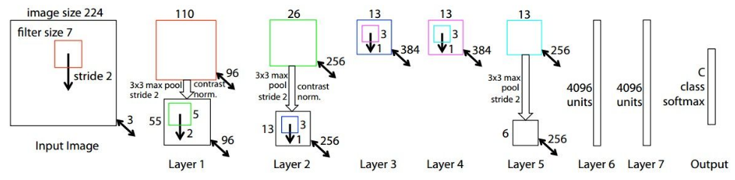

Improvement over AlexNet

Deconvnet Techniques for Visualization

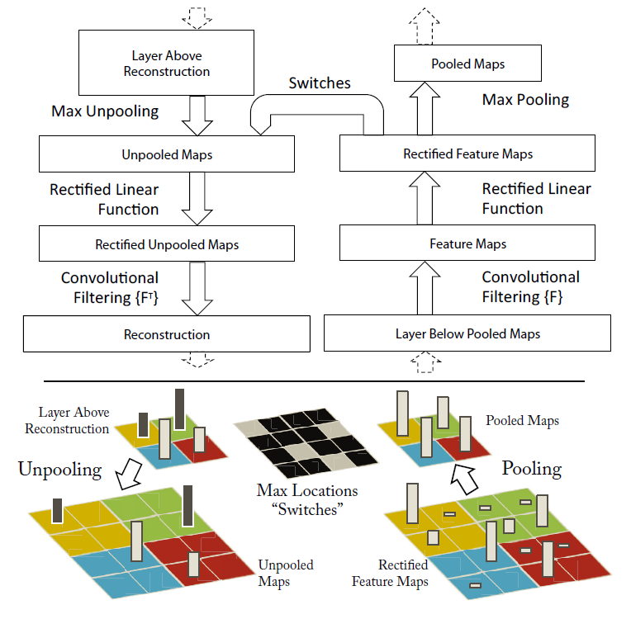

Convolution -> Rectification -> Pooling

Unpooling

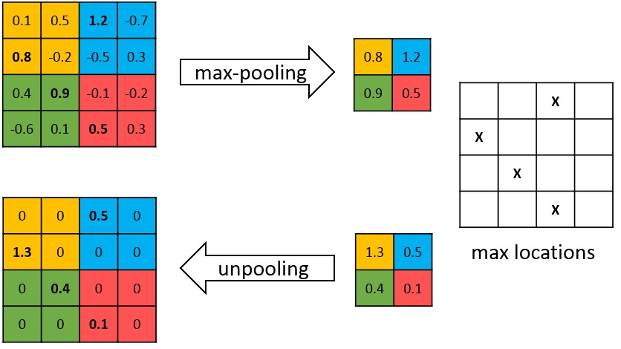

Max pooling operation is non-invertible, however we can obtain an approximate inverse by recording the locations of the maxima within each pooling region, as in the figure above.

Rectification (Activation Function)

Since ReLU is used as the activation function, and ReLU is to keep all values positive while make negative values become zero. In the reverse operation, we just need to perform ReLU again.

Deconv

**Conv (Blue is input, cyan is output)**

**Deconv (Blue is input, cyan is output)**

Modifications of AlexNet Based on Visualization Results

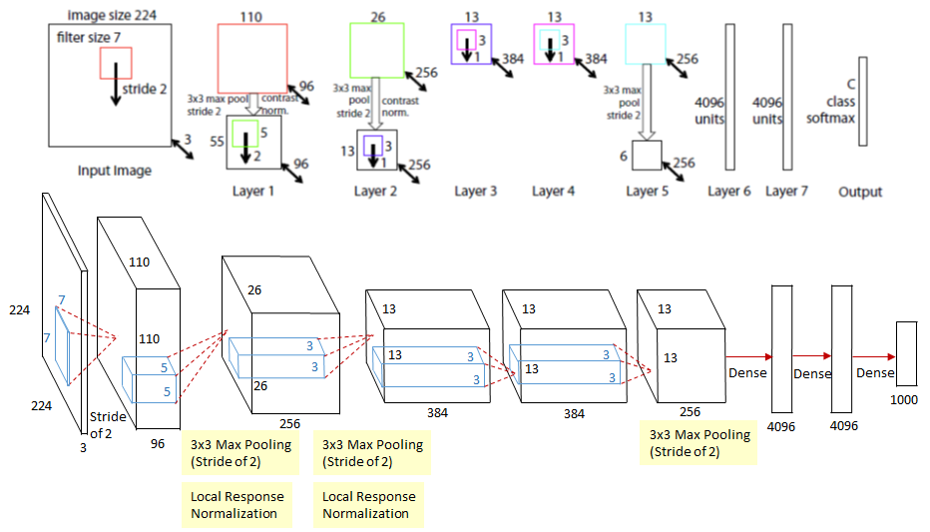

ZFNet is redrawn as the same style of AlexNet for the ease of comparison. To solve the two problems observed in layer 1 and layer 2, ZFNet makes two changes.

* Reduced the 1st layer filter size from 11x11 to 7x7.
* Made the 1st layer stride of the convolution 2, rather than 4.

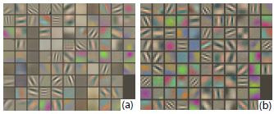

Layer 1: (a) More mid-frequencies in ZFNet, (b) Extremely low and high frequencies in AlexNet

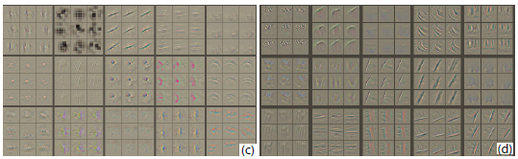

Layer 2: (c) Aliasing artifacts in AlexNet and (d) much cleaner features in ZFNet